|  |
| --- |
| Circle Language Spec: Commands |

## Parameters in a Command Reference in a Diagram

This article demonstrates a situation of command objects.

This article illustrates how parameters in a command reference look in a diagram.

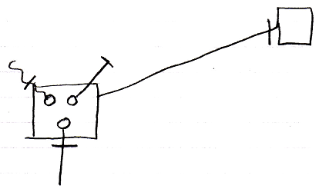

The larger square on the left is a command reference. It is tied to its reference target, the square on the right, with an object line, which is a solid line. The circles inside the square on the left are the parameters of the command reference. The lines tied to those are the parameter passing types. The parameter passings are the lines connected to the circles, that are marked with an access mark. The square on the right could have had the same contents as the square on the left, because both command reference and command definition represent the same command definition.

Either of the squares could have been replaced by a diamond, making the command symbol executable, rather than dormant.